Lab name：**Active Filter** Student ID： B11102112 Name: Chiajui Lee

# Purpose

An active power filter is a device used to eliminate harmonics in power systems, also known as an Active Power Filter (APF). Its primary purpose is to improve power system quality, specifically targeting harmonic elimination. Composed of operational amplifiers (OPAs), resistors, capacitors and other components, these filter circuits operate by utilizing the OPA's negative feedback to achieve frequency-selective signal processing.

Key advantages include:

* High gain capability
* High Q factor performance
* Compact physical size

These characteristics have led to their widespread application in electronic circuits.

# Steps

1. Construct the circuit as specified in the problem using operational amplifiers (OPAs), capacitors, and resistors.
2. Connect the power supply to provide +10V to pin 8 and -10V to pin 4 of the operational amplifier (OPA).
3. Measure the output results using an oscilloscope.

# Data

* 1. **Low-Pass Circuit**

1. Circuit diagram

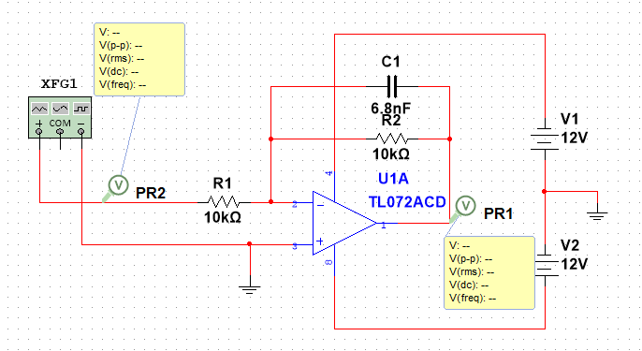

1. Output waveform
   1. Vin(f) = 100Hz

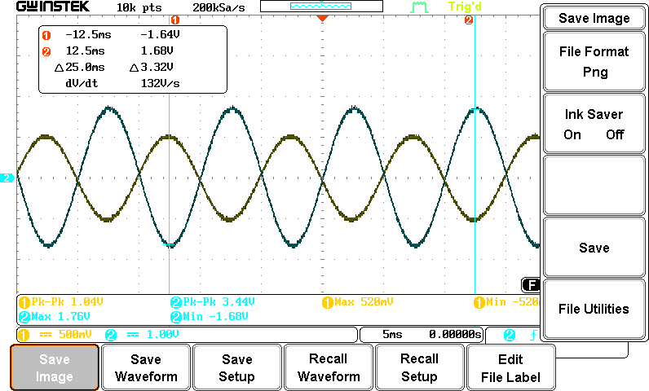

* 1. Vin(f) = 5kHz

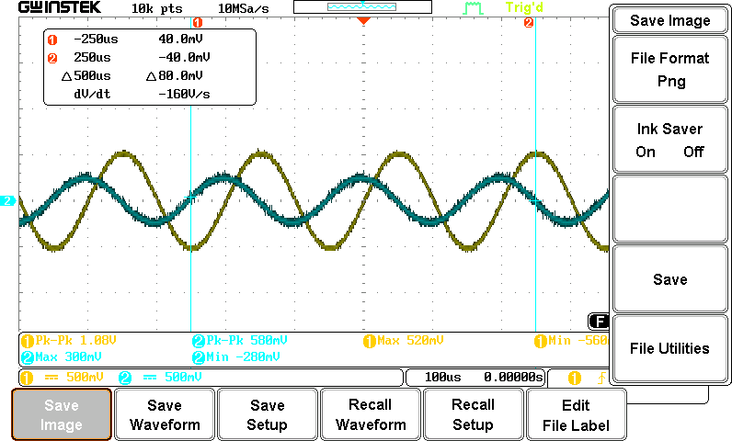

* 1. Output result



Vin(f) - Vo values

4

3.5

3

2.5

2

1.5

1

0.5

0

0

1000

2000

3000

4000

5000

6000

|  |  |  |  |  |  |  |  |  |  |  |  |  |
| --- | --- | --- | --- | --- | --- | --- | --- | --- | --- | --- | --- | --- |
| Vin(f) | 100 | 200 | 500 | 1k | 1.5k | 2k | 2,5k | 3k | 3.5k | 4k | 4.5k | 5k |
| Vo | 3.44 | 3.32 | 2.88 | 2.04 | 1.56 | 1.24 | 1.08 | 0.92 | 0.76 | 0.7 | 0.64 | 0.56 |

|  |  |  |  |  |  |
| --- | --- | --- | --- | --- | --- |
|  |  |  |  |  |  |
|  |  |  |  |  |  |
|  |  |  |  |  |  |
|  |  |  |  |  |  |
|  |  |  |  |  |  |
|  |  |  |  |  |  |
|  |  |  |  |  |  |
|  |  |  |  |  |  |

## **High-Pass Circuit**

* 1. Circuit diagram

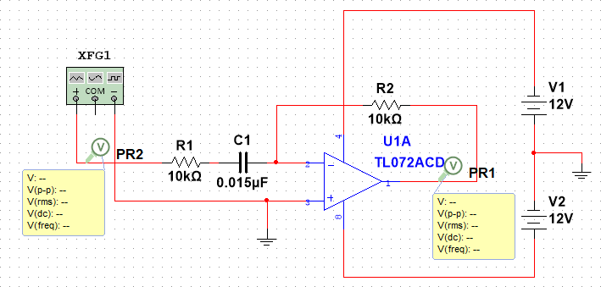

* 1. Output waveform
     1. Vin = 100Hz

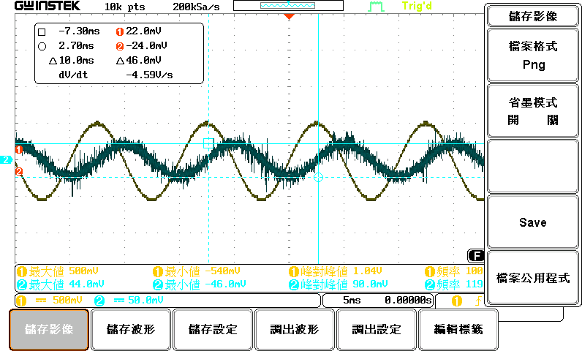

* + 1. Vin = 5KHz

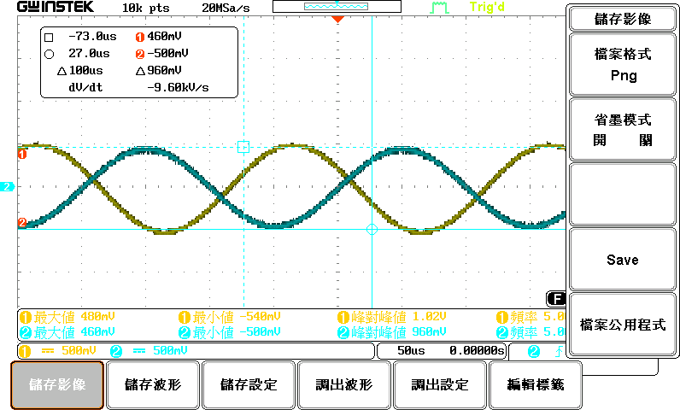

* + 1. Output Result



Vin(f) - Vo values

1.2

1

0.8

0.6

0.4

0.2

0

0

1000

2000

3000

4000

5000

6000

|  |  |  |  |  |  |  |  |  |  |  |  |  |
| --- | --- | --- | --- | --- | --- | --- | --- | --- | --- | --- | --- | --- |
| Vin(f) | 100 | 200 | 500 | 1k | 1.5k | 2k | 2,5k | 3k | 3.5k | 4k | 4.5k | 5k |
| Vo | 0.188 | 0.22 | 0.342 | 0.512 | 0.65 | 0.792 | 0.872 | 0.94 | 1 | 1.02 | 1.04 | 1.06 |

|  |  |  |  |  |  |
| --- | --- | --- | --- | --- | --- |
|  |  |  |  |  |  |
|  |  |  |  |  |  |
|  |  |  |  |  |  |
|  |  |  |  |  |  |
|  |  |  |  |  |  |
|  |  |  |  |  |  |

# Reflections

This lab session deepened my comprehension of high-pass and low-pass circuit applications. These fundamental electronic circuits - composed of resistors, capacitors, and other components - selectively filter signals based on their cutoff frequencies. While electronics courses previously covered their theoretical principles and analytical methods, the practical applications remained unclear until this hands-on experiment.

A key revelation was their use in **audio system equalization**:

* **Tweeters** (high-frequency speakers) receive filtered signals via **high-pass circuits**
* **Woofers** (low-frequency speakers) operate through **low-pass circuits**
* **Frequency tailoring**: Adjusting the cutoff frequencies enables precise control over bass/treble

emphasis

**Educational Value**:  
The experiment transformed abstract theory into tangible understanding, demonstrating how:

1. Unfiltered audio signals would produce a flat frequency response
2. Human hearing preferences favor emphasized highs/lows
3. Active/passive filter designs shape sound characteristics

This integration of theoretical knowledge with real-world implementation fundamentally enhanced my appreciation of circuit design's practical significance.